CONSISTENCY AND STABILITY OF MULTI-METHOD EXPLAINABLE AI IN XGBOOST MANUFACTURING DEFECT PREDICTION

Author(s)

Abstract – This study evaluates the consistency and stability of five Explainable Artificial Intelligence (XAI) methods, namely SHAP, LIME, ELI5, Partial Dependence Plot (PDP), and Individual Conditional Expectation (ICE), applied to an XGBoost model for manufacturing defect prediction, operationalizing an evaluation framework previously proposed only conceptually. The XGBoost model was trained on the Predicting Manufacturing Defects Dataset (3,240 observations, 16 features) with class imbalance handled via sample weighting; the five XAI methods then extracted normalized feature importance scores. Explanation quality was evaluated using three mathematical metrics, namely feature attribution entropy, inter-method Spearman rank correlation, and a stability index, combined into a single equally weighted composite score. The model achieved an accuracy of 94.75%, an AUC-ROC of 0.8346, and a recall of 98.90% for the defective class. Four features, namely MaintenanceHours, DefectRate, QualityScore, and ProductionVolume, consistently ranked highest across all methods, with an average Spearman correlation of 0.8097, confirming interpretation reliability. PDP obtained the highest composite score (0.684) due to its stability and rank consistency, whereas SHAP, despite the highest Spearman correlation (0.873), ranked last due to greater instability under small input perturbations (stability index 0.4771). These findings indicate that the theoretical consistency of an XAI method does not necessarily guarantee its practical stability. The originality of this study lies in operationalizing a measurable and replicable XAI evaluation framework, providing manufacturing practitioners an objective basis for selecting appropriate XAI methods to support transparent, accountable defect detection.
Keywords: Explainable Artificial Intelligence; XGBoost; manufacturing defect prediction; quantitative XAI evaluation; stability index

I. INTRODUCTION

Mathematics and computing underlie modern data analysis, including machine learning, which not only builds predictive models but also evaluates the quality of the resulting decisions. The integration of machine learning and Explainable Artificial Intelligence (XAI) is important to build an accurate, transparent, and accountable system, as affirmed in various high-risk domains ranging from health services (Metta et al., 2024) to the identification of determinants of stunting prevalence in toddlers (Amalia Pasaribu et al., 2026).
XGBoost, as a gradient boosting-based ensemble method, is widely used in tabular-type production data due to its high performance and much lower computing costs compared to more complex deep learning architectures (Bousdekis et al., 2023; Rodriguez-Fernandez & Camacho, 2024; Saberironaghi et al., 2023). In the main reference study, the XGBoost model trained on the manufacturing production defect dataset achieved an accuracy of 95.37% and an AUC of 0.8826, with a 99.27% recall for the defective class (Marín Díaz, 2025a), although handling class imbalance remains a common challenge in XGBoost-based prediction tasks across various industrial applications (Alnahhal et al., 2026).
The black-box nature of models such as XGBoost complicates the understanding of the decision-making process, a challenge that grows more pronounced with increasing model architecture complexity (Santoso et al., 2025) and constitutes an operational requirement within the human-centric AI framework for Industry 5.0 applications (Rožanec et al., 2023). XAI methods such as SHAP, LIME, ELI5, Partial Dependence Plot (PDP), and Individual Conditional Expectation (ICE) are widely used to identify the most influential features, both in the manufacturing context (Aboulhosn et al., 2024; Hong et al., 2025; Mishra et al., 2023) and in other domains such as stunting (Amalia Pasaribu et al., 2026). SHAP provides a theoretical consistency guarantee based on Shapley values that LIME does not possess, making the two methods tend to complement each other (Salih et al., 2025). In the main reference study, all five XAI methods consistently identified MaintenanceHours, DefectRate, and QualityScore as the most influential features affecting product defect status (Marín Díaz, 2025a).
The quality of XAI explanations also needs to be evaluated systematically, encompassing properties such as correctness, compactness, and continuity/consistency .(Nauta et al., 2023). This gap is cross-domain in nature: 43% of XAI studies in cardiology conducted no explanation quality evaluation at all (Salih et al., 2024), while other studies have emphasized the importance of quantitatively evaluating feature ranking consistency using Spearman correlation and Kendall's W test (Thinn & Saeed, 2026), as well as systematically evaluating the consistency of local explanation methods (Metta et al., 2024). In the main reference study, a mathematical framework for evaluating XAI explanation quality, encompassing feature attribution entropy, Spearman rank correlation, and a stability index, was only proposed conceptually, with its quantitative implementation remaining future work (Marín Díaz, 2025a).
The relevance of machine learning and XAI in manufacturing is particularly strong for defect prediction and quality control, given that misclassification of product defects directly affects end-user safety and production costs (Rožanec et al., 2023).Previous studies have demonstrated the benefits of combining predictive models with XAI across various domains, such as employee attrition analysis (Marín Díaz et al., 2023), business decision-making (Marín Díaz et al., 2025), and chemical quality management (Marín Díaz, 2025b); however, all of these, including the main reference study, remain focused on visualization and descriptive interpretation without quantitative evaluation. Based on this gap, this study aims to build a defect prediction model on manufacturing data using XGBoost integrated with five XAI methods (SHAP, LIME, ELI5, PDP, and ICE), while also quantitatively implementing the evaluation framework of feature attribution entropy, Spearman rank correlation, and stability index, which had previously only been proposed conceptually in the reference study (Marín Díaz, 2025a; Nauta et al., 2023; Thinn & Saeed, 2026).

II. METHODS

A. Research Design
This study uses an experimental quantitative-computational design, by extending the supervised defect prediction pathway and the XAI explanatory layer of (Marín Díaz, 2025a) without including the fuzzy clustering (K-means) pathway that is also discussed in the paper. The main contribution of this study lies in the quantitative implementation of the XAI evaluation framework which in the new reference research is conceptually proposed (Section 3.4), including the entropy of feature attribution, the correlation of Spearman ratings between methods, and the stability index.
B. Datasets and Preprocesses
This study uses a manufacturing defect dataset consisting of 3,240 observations and 16 production process variables, with the binary target variable DefectStatus, following the dataset structure at (Marín Díaz, 2025a). The dataset exhibits class imbalance, with the defective class accounting for 84.0% and the non-defective class accounting for 16.0%.
$x_{i,j}^{norm}=\frac{x_{i,j}-min⁡\left(x_{⋅,j}\right)}{max⁡\left(x_{⋅,j}\right)-min⁡\left(x_{⋅,j}\right)}, j=1,…,16$ | (1)
$x_{i,j}$= original value of feature-$j$ for observation-$i$; $x_{i,j}^{norm}$= value after normalization to [0,1]; $x_{.,j}$= vector of all values of feature-$j$; $min⁡\left(x_{.,j}\right)$, $max⁡\left(x_{.,j}\right)$= minimum and maximum values of feature-$j$; $i=1,…,N$with $N=3,240$; $j=1,…,16$.
The dataset was then split into training data and testing data with an 80:20 ratio using stratified split (Marín Díaz, 2025a)
C. Predictive Model: XGBoost
The defect prediction model is built using the Extreme Gradient Boosting (XGBoost) algorithm, which builds an ensemble of classification trees to approximate the function $f:R^{16}→\left[0 , 1\right]$ (Chen & Guestrin, 2016; Marín Díaz, 2025a):
${\hat{y}}_{i}=σ\left(\sum_{k=1}^{K}{f_{k}}\left(x_{i}\right)\right), f_{k}∈F$ | (2)
${\hat{y}}_{i}$= predicted defect probability for observation-$i$; $x_{i}$= vector of 16 input features; $K$= number of trees in the ensemble; $f_{k}$= the $k$-th decision tree from the function space $F$; $σ\left(⋅\right)$= logistic sigmoid function.
The model was trained by minimizing a regularized binary cross-entropy loss function:
$L\left(θ\right)=\sum_{i=1}^{N}{l}\left(y_{i} , {\hat{y}}_{i}\right)+\sum_{k=1}^{K}{Ω}\left(f_{k}\right)$ | (3)
$L\left(θ\right)$= total loss function; $y_{i}$= actual label; $l\left(y_{i} , {\hat{y}}_{i}\right)$= logistic loss; $Ω\left(f_{k}\right)$= complexity regularization term for the $k$-th tree.
To address class imbalances, each observation is weighted by the sample inversely proportional to its class proportions — an approach consistent with recent comparative studies on class imbalance management strategies in XGBoost-based models (Alnahhal et al., 2026).
Algorithm 1 — XGBoost Model Training
Input: Normalized dataset $D_{train},D_{test}$
Output: Trained model $f\left(⋅\right)$, performance metrics on $D_{test}$
- Calculate the class proportions in $D_{train}$: $n_{pos}$(defect label) and $n_{neg}$(non-defect label).
- Calculate sample weight $w_{i}$: $w_{i}=n_{pos}/n_{neg}$if $y_{i}=0$; $w_{i}=1$if $y_{i}=1$.
- Initialize the XGBoost model with hyperparameter configuration ($K$, maximum depth, learning rate, regularization parameters).
- Train the model on $D_{train}$by minimizing $L\left(θ\right)$, using $w_{i}$as sample weight.
- Apply the model $f\left(⋅\right)$to $D_{test}$to obtain ${\hat{y}}_{i}$.
- Convert ${\hat{y}}_{i}$into a binary label using a threshold of 0.5.
- Calculate accuracy, AUC-ROC, precision, recall, F1-score, Cohen's kappa, and MCC from the comparison of $y_{i}$with the results of Step 6.
- Return $f\left(⋅\right)$along with all metrics from Step 7.
D. Lapisan Explainability (XAI)
Five XAI techniques are applied to the trained XGBoost model, following the framework (Marín Díaz, 2025a).
1) SHAP calculates the contribution of each feature $j$ to the prediction based on Shapley's value of cooperative game theory (Lundberg & Lee, 2017):
$$ϕ_{j}= \sum_{S⊆N∖\left\{j\right\}}{\frac{∣S∣!\left(∣N∣-∣S∣-1\right)!}{∣N∣!}\left[f\left(S∪\left\{j\right\}\right)-f\left(S\right)\right]}$$ | (4)
$ϕ_{j}$= SHAP value of feature-$j$; $N$= the set of all 16 features; $S$= a subset of features excluding feature $j$; $∣S∣$= size of the subset $S$; $f\left(S\right)$= model prediction using only the features in $S$known; fractional weight = Shapley weight. With the additivity property $f\left(x\right)=ϕ_{0}+\sum_{j=1}^{16}{ϕ_{j}}$, where $ϕ_{0}$= the expected value of the model over the background data.
2) LIME approaches the model locally around an instance with a simple surogat model $g$, by minimizing (Ribeiro et al., 2016):
$L\left(f , g , π_{x}\right)+Ω\left(g\right)$ | (5)
$f$= the original black-box model; $g$= the interpretable surrogate model; $x$= the instance being explained; $π_{x}$= the proximity kernel; $L\left(f , g , π_{x}\right)$= local fidelity loss; $Ω\left(g\right)$= complexity regularization of $g$.
3) ELI5. For tree-based models such as XGBoost, ELI5 calculates the contribution of features through decision path tracing, which is aggregating the information gain from each split along the tree path that an agency travels (Marín Díaz, 2025a):
${\text{Contribution}}_{j}\left(x\right)=\sum_{t∈T_{x}}{G_{j}^{t}}$ | (6)
$T_{x}$= the set of trees traversed by instance $x$; $G_{j}^{t}$= information gain of feature-$j$ at tree-$t$.
4) PDP and ICE. The PDP visualizes the average effect of a feature $x_{s}$ on the model's prediction by marginalizing the other features, while the ICE displays the prediction curve at the individual agency level so that the average of the entire ICE curve reproduces the PDP curve (Goldstein et al., 2015):
$\hat{PD}\left(x_{s}\right)=\frac{1}{N}\sum_{i=1}^{N}{f}\left(x_{s} , x_{∖s}^{\left(i\right)}\right)$ | (7)
$ICE^{\left(i\right)}\left(x_{s}\right)=f\left(x_{s} , x_{∖s}^{\left(i\right)}\right)$ | (8)
$x_{s}$= the target feature being varied; $x_{s}^{\left(i\right)}$= the feature value held fixed for observation-$i$; $\overset{‾}{PD}\left(x_{s}\right)$= the average prediction across all $N$observations; $ICE^{\left(i\right)}\left(x_{s}\right)$= the curve for a single observation-$i$.
Algorithm 2 — Application of Five XAI Techniques
Input: Trained model $f\left(⋅\right)$, test data $D_{test}$, list of 16 features
Output: Five normalized importance vectors $p_{j}^{\left(m\right)}$, $m\left.∈\right\{$SHAP, LIME, ELI5, PDP, ICE$\left.\}\right.$
- SHAP: Initialize TreeExplainer on $f\left(⋅\right)$. Calculate $ϕ_{j}$for all observations in $D_{test}$. Aggregation: $I_{j}^{SHAP}=\frac{1}{N_{test}}\sum_{i}{∣}ϕ_{j}^{\left(i\right)}∣$.
- LIME: Initialize LimeTabularExplainer with $D_{train}$as background data. Generate local explanations $g$for sampled instances in $D_{test}$, extract feature weights, aggregate into $I_{j}^{LIME}$.
- ELI5: Extract gain importance $G_{j}$directly from the tree structure of $f\left(⋅\right)$, without requiring $D_{test}$.
- PDP: Calculate the $\overset{‾}{PD}\left(x_{j}\right)$curve for each feature-$j$ using $D_{test}$as background data. Set $I_{j}^{PDP}$= range (max−min) of the curve.
- ICE: Calculate the $ICE^{\left(i\right)}\left(x_{j}\right)$curve for each instance-$i$. Set $I_{j}^{ICE}$= the average range of the ICE curves across all instances.
- Normalize each $I_{j}^{\left(m\right)}$into $p_{j}^{\left(m\right)}=∣I_{j}^{\left(m\right)}∣/\sum_{j=1}^{16}{∣}I_{j}^{\left(m\right)}∣$.
- Return the five vectors $p_{j}^{\left(m\right)}$of dimension 16, each summing to 1.
E. XAI Quantitative Evaluation Framework
Kontribusi utama penelitian ini terletak pada implementasi kuantitatif tiga metrik evaluasi kualitas penjelasan XAI yang pada (Marín Díaz, 2025a) baru diusulkan secara konseptual, seluruhnya dihitung dari vektor atribusi/importance fitur $p_{j}$ yang telah dinormalisasi (sum of $=1$) agar sebanding lintas metode, sejalan dengan properti correctness dan compactness pada taksonomi evaluasi XAI (Nauta et al., 2023):
1) Entropy Attribution Features:
$H\left(ϕ\right)=-\sum_{j=1}^{p}{ϕ_{j}}\log{ϕ_{j}}$ | (9)
$H\left(ϕ\right)$= Shannon entropy of the attribution vector; $ϕ_{j}≡p_{j}$= normalized importance weight of feature-$j$; $p$= number of features ($p=16$).
A low value indicates a concentrated importance on a few features; a high value indicates a more even spread.
2) Spearman Rank Correlations: calculated in pairs between the five methods of the vector $p_{j}$, forming a matrix, following the approach validated on the latest XAI intermethod feature ranking consistency study $5×5$ (Thinn & Saeed, 2026).
3) Stability Index. Measure the resistance of explanations to small noise in the input. Because the five XAI methods have fundamentally different computational bases, the stability index is calculated with an approach tailored per group of methods, but still at a comparable scale:
SHAP and LIME (explainer based on instance location): Gaussian noise $ε∼N\left(0 , σ^{2}\right)$is added to the input, the attribution vector is recalculated and re-normalized, then the difference is measured using the Euclidean norm, averaged over a number of instances:
$S^{\left(m\right)}=\frac{1}{N}\sum_{i=1}^{N}{∥{\hat{ϕ}}^{\left(m\right)}\left(x^{\left(i\right)}\right)-{\hat{ϕ}}^{\left(m\right)}\left(x^{\left(i\right)}+ε\right)∥}, m∈\left\{\text{SHAP, LIME}\right\}$ | (10)
$S^{\left(m\right)}$= stability index of method-$m$; ${\hat{ϕ}}^{\left(m\right)}\left(x^{\left(i\right)}\right)$= normalized attribution for the original instance; ${\hat{ϕ}}^{\left(m\right)}\left(x^{\left(i\right)}+ε\right)$= attribution after noise is added; $ε∼N\left(0 , σ^{2}\right)$= Gaussian noise; $∥⋅∥$= Euclidean norm. For PDP/ICE, noise is applied to the background data; for ELI5, $S^{\left(ELI5\right)}=0$ by definition (structural invariance).
- PDP and ICE (depend on background data for feature marginalization): small noise is applied to the background data, the curve is recalculated, and the difference in the (normalized) importance range of the curves is measured — averaged across several independent realizations.
- ELI5 (a global model property, not dependent on test data): since gain importance is determined purely by the structure of the already-trained tree, this method is structurally invariant to input perturbation ($S^{\left(ELI5\right)}=0$ by definition). As a complementary metric, ELI5's sensitivity to variations in the training process is tested through bootstrap resampling of the training data followed by model retraining.
F. Composite comparison score. The three metrics above are combined into a single composite score with equal weighting (1/3 for each component — entropy, average Spearman correlation, and the stability index, whose scale has been inverted so that higher values indicate better performance), yielding the final ranking of the five XAI methods.
${\text{Skor}}^{\left(m\right)}=\frac{1}{3}\left[(1-H_{norm}^{\left(m\right)})+{\overline{ρ}}^{\left(m\right)}+(1-S_{norm}^{\left(m\right)})\right]$ | (11)
$H_{norm}^{\left(m\right)}$, $S_{norm}^{\left(m\right)}$= entropy and stability index of method-$m$ after being normalized to [0,1] and direction-reversed; ${\overline{ρ}}^{\left(m\right)}$= average Spearman correlation of method-$m$ against the other four methods.
Algorithm 3 — Quantitative Evaluation and Composite Score
Input: Five vectors $p_{j}^{\left(m\right)}$from Algorithm 2, model $f\left(⋅\right)$, stability test subset $X_{stab}⊂D_{test}$
Output: Table of composite scores and final ranking of the five XAI methods
- Entropy: For each method $m$, calculate $H^{\left(m\right)}=-\sum_{j=1}^{16}{p_{j}^{\left(m\right)}}\log{p_{j}^{\left(m\right)}}$. Normalize to $H_{norm}^{\left(m\right)}∈\left[0 , 1\right]$.
- Spearman correlation: Calculate the $5×5$pairwise rank correlation matrix across the five vectors $p_{j}^{\left(m\right)}$. For each $m$, calculate ${\overline{ρ}}^{\left(m\right)}$against the other four methods.
- Stability — SHAP & LIME: Add $ε∼N\left(0 , σ^{2}\right)$to each instance in $X_{stab}$, recalculate the normalized attribution, and compute $S^{\left(m\right)}$.
- Stability — PDP & ICE: Repeat Step 3 with noise applied to the background data, and repeat over $N_{trial}$independent realizations, averaging the results.
- Stability — ELI5: Set $S^{\left(ELI5\right)}=0$. As a complementary metric, perform bootstrap resampling of $D_{train}B$times, retrain the model, and calculate the variance in gain importance.
- Normalize all $S^{\left(m\right)}$to $S_{norm}^{\left(m\right)}∈\left[0 , 1\right]$.
- Calculate ${\text{Score}}^{\left(m\right)}=\frac{1}{3}\left[H_{norm}^{\left(m\right)}+{\overline{ρ}}^{\left(m\right)}+\left(1-S_{norm}^{\left(m\right)}\right)\right]$for each $m$.
- Rank the five methods based on ${\text{Score}}^{\left(m\right)}$from highest to lowest.
- Return the table of $H^{\left(m\right)}$, ${\overline{ρ}}^{\left(m\right)}$, $S^{\left(m\right)}$, ${\text{Score}}^{\left(m\right)}$, and the final ranking.

III. RESULTS AND DISCUSSION

A. Data Characteristics and Validity of Data Classification
The dataset used consists of 3,240 observations and 16 numerical features with the binary target variable DefectStatus. Checking the blank value shows that there are no missing values in the entire column, so no imputation is required. The distribution of the target class showed a considerable imbalance, namely 2,723 observations (84.04%) labeled defective and 517 observations (15.96%) labeled undefective, with an imbalance ratio of 5.27:1 (Table 1, Figure 1). After the rehearsal data distribution using a stratified split of 80:20, the proportion of defective classes in the rehearsal data (84.03%) and the test data (84.10%) remained consistent with the proportion of the initial population, confirming that the data-sharing procedure did not introduce sample bias against the majority or minority classes.

Table 1. Target class distribution before and after the stratified split
Data subset | Class 0 (Non-Defective) | Class 1 (Defective) | Proportion of class 1 | Number of observations
Overall population | 517 (15.96%) | 2,723 (84.04%) | 84.04% | 3,240
Training data (80%) | 414 | 2,178 | 84.03% | 2,592
Test data (20%) | 103 | 545 | 84.10% | 648

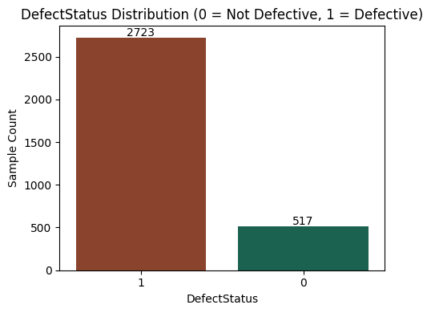
Figure 1 DefectStatus target class distribution (0 = Non-Defect, 1 = Defect)

The validity of feature interpretation was further examined through a Variance Inflation Factor (VIF) test on the sixteen features after Min-Max normalization. All features yielded VIF values in the range of 1.002-1.006, well below the commonly used multicollinearity threshold (VIF ≥ 5), indicating no meaningful evidence of collinearity among features. This finding is consistent with the Pearson correlation matrix between features (Figure 2), which shows that the majority of feature pairs have correlation coefficients close to zero. This condition is methodologically important, as it ensures that the importance scores produced by the five XAI methods in the subsequent subsection can be directly interpreted as each feature's individual contribution, without distortion from redundancy effects among highly correlated predictors..

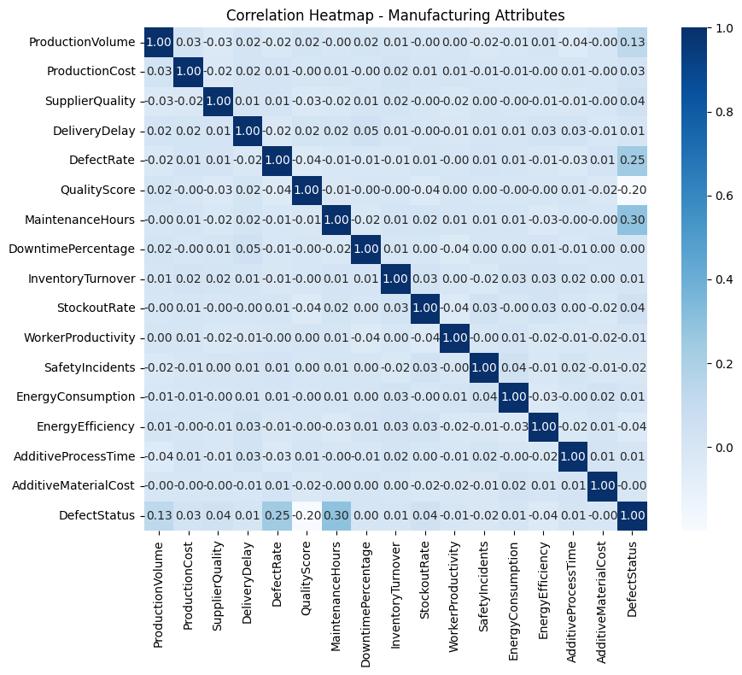
Figure 2 Pearson correlation matrix among 16 manufacturing features and the DefectStatus target variable

B. Predictive Performance of the XGBoost Model
The XGBoost model with sample weighting to handle class imbalance achieved an accuracy of 94.75% and an AUC-ROC of 0.8346 on the test data (Table 2). A Matthews Correlation Coefficient (MCC) of 0.7928 and a Cohen's Kappa of 0.7852 indicate a substantial level of agreement between the model's predictions and the actual labels, and are more resistant to class imbalance bias than accuracy alone. The per-class performance breakdown (Table 3, Figure 3) shows that the model performs better in detecting the majority class (defective), with a recall of 98.90%, compared to the minority class (non-defective), with a recall of 73.00%, a pattern consistent with the common modeling challenges posed by data with high class imbalance.

Table 2 Overall performance metrics of the XGBoost model on the test data
Metric | Value | Metric | Value
Accuracy | 0.9475 | F1-score | 0.9694
AUC-ROC | 0.8346 | MCC | 0.7928
PR-AUC | 0.9293 | Cohen's Kappa | 0.7852
Precision | 0.9506 | Recall | 0.9890

Table 3 Per-class classification report on the test data (n = 648)
Class | Precision | Recall | F1-score | Number of data
Non-Defective (0) | 0.93 | 0.73 | 0.82 | 103
Defective (1) | 0.95 | 0.99 | 0.97 | 545
Macro average | 0.94 | 0.86 | 0.89 | 648

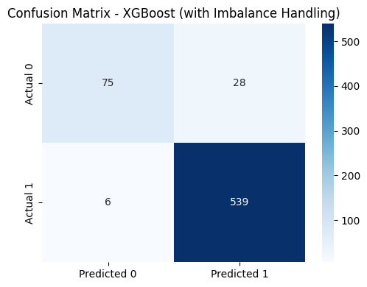
Figure 3 Confusion matrix model XGBoost on test data with class imbalance handling

C. Feature Importance Based on the Five XAI Methods
The five XAI methods were applied to the trained XGBoost model, producing normalized feature importance vectors (sum = 1) to enable comparability across methods. The computational validity of SHAP was verified through an additivity test, with an average discrepancy of 0.00000002 and a maximum discrepancy of 0.00000042 between the sum of Shapley values and the model output, well below the numerical error tolerance of 1×10⁻⁴, confirming that the SHAP explainer had been computed correctly. Figure 4 presents the SHAP summary plot visualizing the distribution of SHAP values for each feature across all test data instances, along with the direction of their influence on the prediction. The validity of ELI5 was further examined by comparing the resulting feature ranking against XGBoost's built-in gain-importance ranking, and both produced identical feature orderings across all 16 features, confirming that ELI5's decision-path tracing method accurately represents the model's importance structure.

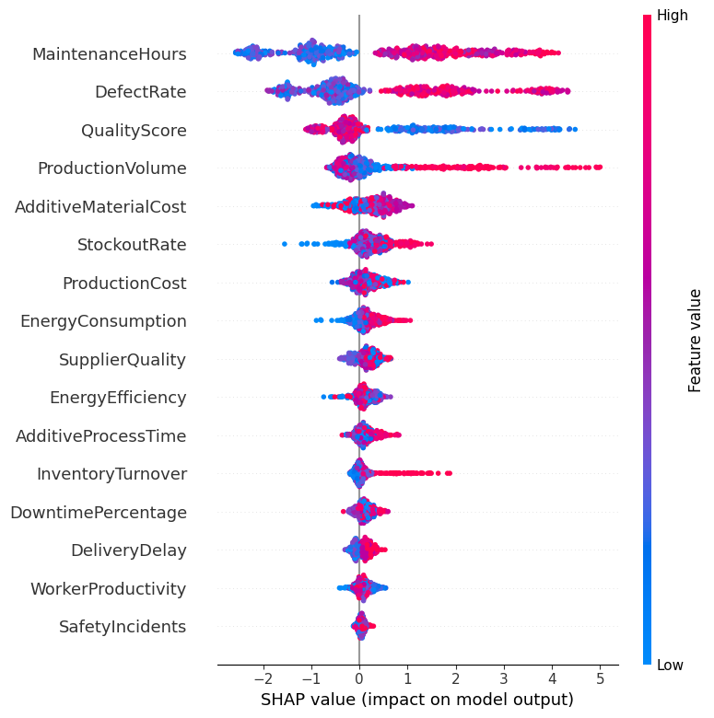
Figure 4 SHAP summary plot: the distribution of SHAP values and the direction of each feature's influence on production defect prediction

Figure 5 presents the complete matrix of normalized importance scores for all 16 features across the five XAI methods in the form of a heatmap. The pattern observed is that the top four features — MaintenanceHours, DefectRate, QualityScore, and ProductionVolume — consistently produced the highest values (darkest colors) across all five methods, although the specific ordering between MaintenanceHours and DefectRate swapped positions between methods (Table 4). As a complement, Figure 6 displays the Partial Dependence Plot (bold line) and Individual Conditional Expectation (individual lines) for the two highest-ranked features, namely MaintenanceHours and DefectRate, which show the direction of the relationship between feature values and the predicted probability of a defect at both the population level and the individual instance level.

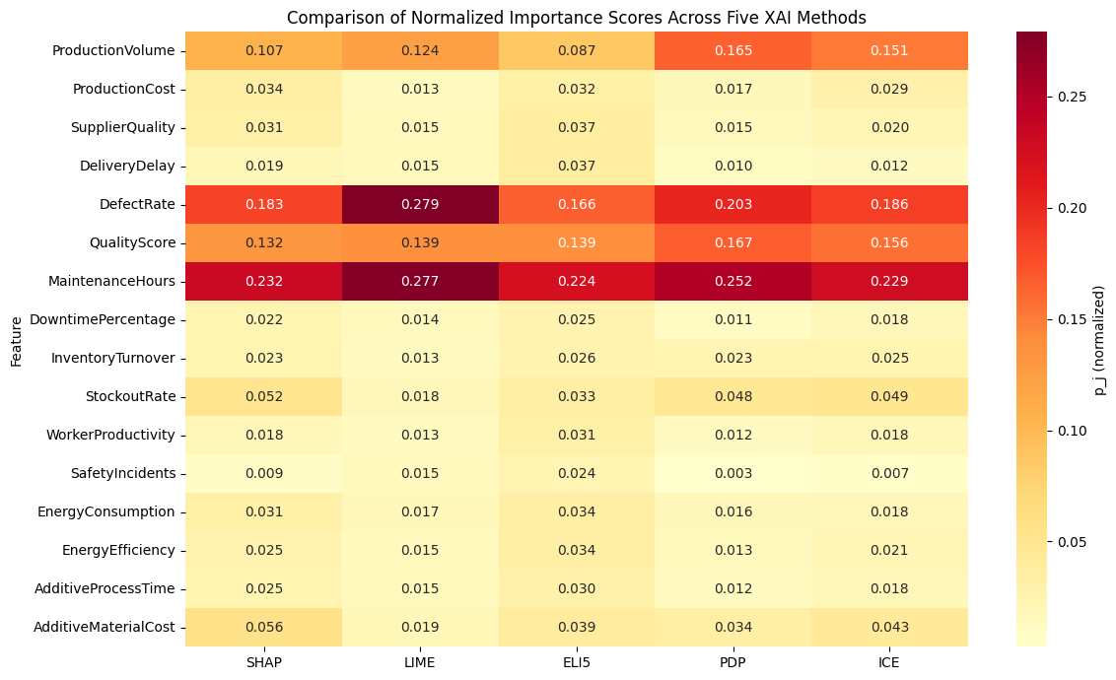
Figure 5 Normalized feature importance score matrix for 16 features in all five XAI methods

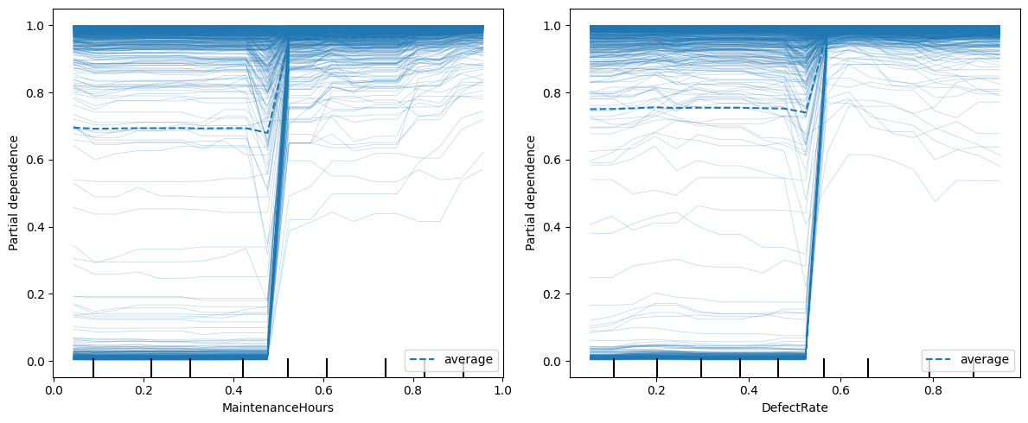
Figure 6 Partial Dependence Plot and Individual Conditional Expectation for the MaintenanceHours and DefectRate features

Table 4 Ranking of the top four features for each XAI method
Rank | SHAP | LIME | ELI5 | PDP | ICE
1 | MaintenanceHours | DefectRate | MaintenanceHours | MaintenanceHours | MaintenanceHours
2 | DefectRate | MaintenanceHours | DefectRate | DefectRate | DefectRate
3 | QualityScore | QualityScore | QualityScore | QualityScore | QualityScore
4 | ProductionVolume | ProductionVolume | ProductionVolume | ProductionVolume | ProductionVolume

D. Feature Attribution Entropy
Normalized entropy measures how concentrated (low values) or dispersed (high values) the importance distribution produced by each method is. The results in Table 5 and Figure 7 show that LIME has the lowest entropy (0.723), meaning its attribution is most concentrated on a small number of features, whereas ELI5 has the highest entropy (0.879), meaning its contribution is most evenly spread across the 16 features. SHAP and ICE occupy intermediate positions, while PDP is relatively close to LIME. This pattern is consistent with the computational basis of each method: LIME builds a local surrogate model that tends to emphasize a handful of the most influential features for a given instance, whereas ELI5 aggregates information gain from all tree splits, thereby also assigning small weights to features with marginal contributions.

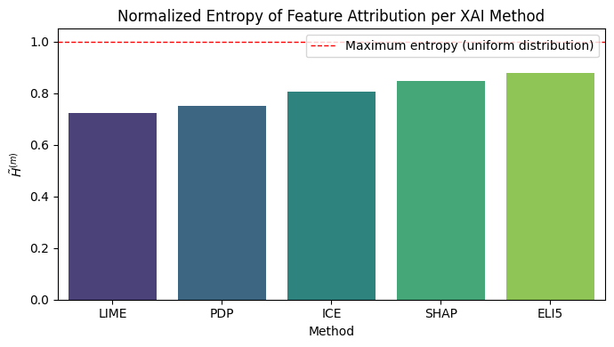
Figure 7 Normalized feature attribution entropy in all five XAI methods

Table 5. Feature attribution entropy values (ordered from most concentrated)
Method | Entropy (H) | Normalized entropy
LIME | 2.0039 | 0.7227
PDP | 2.0866 | 0.7526
ICE | 2.2393 | 0.8077
SHAP | 2.3488 | 0.8471
ELI5 | 2.4367 | 0.8788

E. Cross-Method Feature Ranking Consistency (Spearman Correlation)
The pairwise Spearman rank correlations between the five XAI methods (Table 6, Figure 8) yielded an overall average correlation (rho-bar) of 0.8097, which falls into the high cross-method consistency category. Nevertheless, the correlation matrix reveals a clear clustering pattern: SHAP, PDP, and ICE are very strongly correlated with one another (0.90-0.94), whereas LIME shows the lowest correlations with PDP (0.712) and ICE (0.650), although it remains strongly correlated with SHAP (0.815) and ELI5 (0.859). This pattern is consistent with a fundamental difference between the methods: SHAP, PDP, and ICE are all derived from systematically evaluating the model across various combinations of feature values, whereas LIME relies on local sampling around a specific instance, making it more susceptible to variation in the importance of mid-to-lower-ranked features.

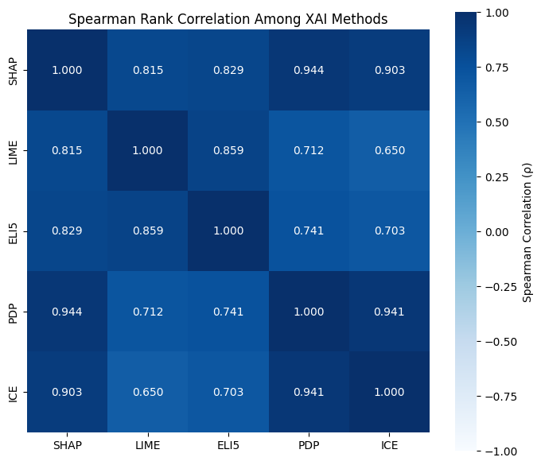
Figure 8 Pairwise Spearman correlation matrix among the feature rankings of the five XAI methods
Table 6. Spearman rank correlation matrix across XAI methods
 | SHAP | LIME | ELI5 | PDP | ICE
SHAP | 1.000 | 0.815 | 0.829 | 0.944 | 0.903
LIME | 0.815 | 1.000 | 0.859 | 0.712 | 0.650
ELI5 | 0.829 | 0.859 | 1.000 | 0.741 | 0.703
PDP | 0.944 | 0.712 | 0.741 | 1.000 | 0.941
ICE | 0.903 | 0.650 | 0.703 | 0.941 | 1.000

F. Cross-Method Stability Index
The stability index measures the robustness of feature attribution to small perturbations in the input (for SHAP and LIME) or to bootstrap resampling of the training data (for ELI5, PDP, and ICE, which are derived from the same model structure). The results in Table 7 and Figure 9 show a striking difference between methods: PDP, ELI5, and ICE yielded the lowest and identical stability index (0.0316), indicating the highest stability/robustness, followed by LIME (0.0586), whereas SHAP yielded the highest stability index (0.4771), approximately 15 times greater than the PDP/ELI5/ICE group. This high stability index value for SHAP is consistent with the nature of Shapley values, which are recalculated individually for each instance based on all feature coalition combinations, such that small perturbations in input values can produce a relatively larger redistribution of contributions among features compared to methods that rely on an already-trained tree structure.

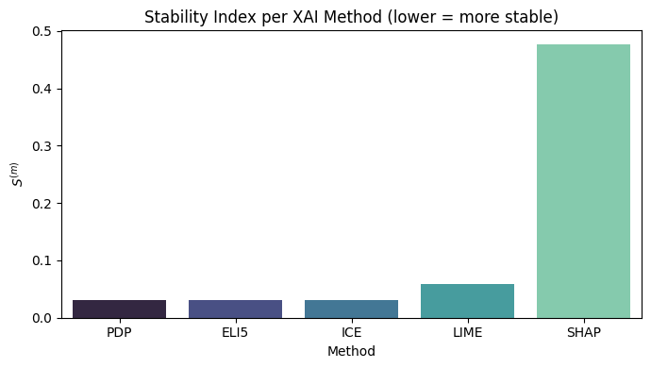
Figure 9 Stability index of the five XAI methods (lower values indicate higher stability)

Table 7 Stability index of the five XAI methods and their computational basis
Method | Stability Index | Computational basis
PDP | 0.0316 | Bootstrap resampling (model-structure proxy)
ELI5 | 0.0316 | Bootstrap resampling (gain-based)
ICE | 0.0316 | Bootstrap resampling (model-structure proxy)
LIME | 0.0586 | Direct input perturbation
SHAP | 0.4771 | Direct input perturbation

G. Composite Score and Final Ranking of XAI Methods
The three evaluation metrics (normalized entropy, average Spearman correlation, and the direction-reversed stability index) were combined with equal weighting (1/3 each) into a single composite score. Table 8 and Figure 10 show that PDP ranked first with a composite score of 0.684, followed by LIME (0.660), ICE (0.654), ELI5 (0.625), and SHAP last with a score of 0.568. This final ranking was primarily driven by stability index performance: the top four methods all had low stability indices, whereas SHAP, despite having the highest average Spearman correlation with the other methods (0.873), was held back to fifth place due to a stability index far higher than that of the other methods.

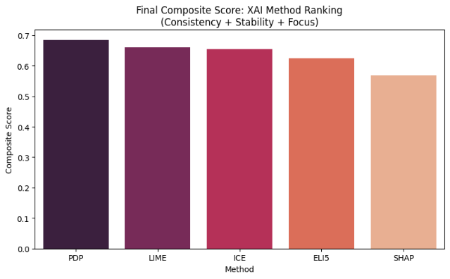
Figure 10 Final ranking of the five XAI methods based on the combined composite score

Table 8 Summary of the three metric components and final composite score of the five XAI methods
Rank | Method | Entropy | Mean rho | Stability | Composite score
1 | PDP | 0.7526 | 0.8346 | 0.0316 | 0.6838
2 | LIME | 0.7227 | 0.7588 | 0.0586 | 0.6602
3 | ICE | 0.8077 | 0.7993 | 0.0316 | 0.6537
4 | ELI5 | 0.8788 | 0.7831 | 0.0316 | 0.6245
5 | SHAP | 0.8471 | 0.8728 | 0.4771 | 0.5675

H. Discussion
The XGBoost model in this study shows performance (accuracy 94.75%; AUC-ROC 0.8346; recall 98.90%) comparable to the reference study (Marín Díaz, 2025a), confirming pipeline replicability and the effectiveness of sample weighting in handling class imbalance (Alnahhal et al., 2026). The consistency of the top four features (MaintenanceHours, DefectRate, QualityScore, ProductionVolume) across all five XAI methods supports the correctness property within the Co-12 taxonomy (Nauta et al., 2023) and aligns with the reference study.
The main finding is the contrast observed for SHAP: although it has the highest Spearman correlation with the other methods (0.873), consistent with its claimed theoretical consistency (0.873), consistent with its claimed theoretical consistency (Salih et al., 2025), SHAP proved to be the least stable (highest stability index), resulting in the lowest composite score. This demonstrates that theoretical consistency does not guarantee practical robustness against input noise, consistent with findings in other domains (Nauta et al., 2023; Salih et al., 2024; Thinn & Saeed, 2026).
In contrast, PDP ranked first due to being stable and consistent relative to SHAP and ICE, as it is computed through systematic marginalization (rather than local sampling), making it more resistant to noise. The implication is that the selection of XAI methods for root cause analysis in high-risk manufacturing settings should be based on quantitative evidence, rather than popularity or theoretical claims (Marín Díaz, 2025a; Marín Díaz et al., 2023; Rožanec et al., 2023). This study fills the quantitative implementation gap that had previously only been proposed conceptually (Marín Díaz, 2025a; Salih et al., 2024). Its limitation lies in the evaluation being conducted on only one dataset and one class imbalance handling strategy, making generalization to other datasets or algorithms a direction for future research.

IV. CONCLUSION

This study built a defect prediction model on manufacturing data using XGBoost integrated with five Explainable Artificial Intelligence (XAI) methods — SHAP, LIME, ELI5, PDP, and ICE — and quantitatively implemented an XAI explanation quality evaluation framework (feature attribution entropy, Spearman rank correlation, and stability index) that had previously only been proposed conceptually in the reference study (Marín Díaz, 2025a). The XGBoost model with class imbalance handling through sample weighting achieved an accuracy of 94.75%, an AUC-ROC of 0.8346, and a recall of 98.90% for the defective class, an achievement comparable to the reference study that confirms the replicability of the pipeline. All five XAI methods consistently identified MaintenanceHours, DefectRate, QualityScore, and ProductionVolume as the most influential features affecting product defect status, demonstrating the correctness of the model's explanations both across methods and across studies.
The average inter-method Spearman correlation of 0.8097 indicates generally high consistency in feature ranking, although LIME showed relatively low agreement with PDP and ICE. In terms of stability, PDP, ELI5, and ICE proved most resistant to small perturbations in the input (stability index of 0.0316), whereas SHAP, despite having the highest average Spearman correlation (0.873), produced the highest stability index (0.4771), placing its composite score last. Based on the combined composite score, PDP ranked first (0.684), followed by LIME (0.660), ICE (0.654), ELI5 (0.625), and SHAP (0.568), quantitatively demonstrating that a theoretical consistency guarantee for an XAI method does not necessarily ensure its practical robustness against small input noise. This study addresses the quantitative implementation gap in the evaluation framework of entropy, Spearman correlation, and stability index that had previously only been proposed conceptually in the reference study (Marín Díaz, 2025a), with the limitation of covering only one dataset and one class imbalance handling strategy, such that generalizing the evaluation framework to other manufacturing datasets, predictive algorithms besides XGBoost, and different class imbalance handling strategies is recommended for future research.
Future research is therefore recommended to generalize the proposed evaluation framework to other manufacturing datasets and industrial domains to test its external validity, and to extend the framework to predictive algorithms beyond XGBoost, such as LightGBM, Random Forest, or deep learning-based models, to examine whether the observed stability–consistency trade-off is model-specific. Alternative class imbalance handling strategies, such as SMOTE or cost-sensitive learning, should also be evaluated to assess their influence on XAI explanation quality.

REFERENCES
Aboulhosn, Z., Musamih, A., Salah, K., Jayaraman, R., Omar, M., & Aung, Z. (2024). Detection of Manufacturing Defects in Steel Using Deep Learning With Explainable Artificial Intelligence. IEEE Access, 12, 99240–99257. https://doi.org/10.1109/ACCESS.2024.3430113
Alnahhal, M., Tabash, M. I., Safi, S. K., Al-Absy, M. S. M., & Mamadiyarov, Z. (2026). A Comparative Study of Imbalance-Handling Methods in Multiclass Predictive Maintenance. Computation, 14(4), 1–22. https://doi.org/10.3390/computation14040088
Amalia Pasaribu, A., Nur Fitriyani Sahamony, Khairil Anwar Notodiputro, & Bagus Sartono. (2026). Explainable Machine Learning Models SHAP-based for Feature Importance Affecting Stunting Prevalence. ComTech: Computer, Mathematics and Engineering Applications, 17(1), 11–22. https://doi.org/10.21512/comtech.v17i1.13732
Bousdekis, A., Lepenioti, K., Apostolou, D., & Mentzas, G. (2023). Data analytics in quality 4.0: literature review and future research directions. International Journal of Computer Integrated Manufacturing, 36(5), 678–701. https://doi.org/10.1080/0951192X.2022.2128219
Chen, T., & Guestrin, C. (2016). XGBoost: A scalable tree boosting system. Proceedings of the ACM SIGKDD International Conference on Knowledge Discovery and Data Mining, 13-17-Augu, 785–794. https://doi.org/10.1145/2939672.2939785
Goldstein, A., Kapelner, A., Bleich, J., & Pitkin, E. (2015). Peeking Inside the Black Box: Visualizing Statistical Learning With Plots of Individual Conditional Expectation. Journal of Computational and Graphical Statistics, 24(1), 44–65. https://doi.org/10.1080/10618600.2014.907095
Hong, J., Hong, Y., Baek, J. W., & Kang, S. W. (2025). Enhancing the Product Quality of the Injection Process Using eXplainable Artificial Intelligence. Processes, 13(3), 1–17. https://doi.org/10.3390/pr13030912
Lundberg, S. M., & Lee, S. I. (2017). A unified approach to interpreting model predictions. Advances in Neural Information Processing Systems, 2017-Decem(Section 2), 4766–4775.
Marín Díaz, G. (2025a). Comparative Analysis of Explainable AI Methods for Manufacturing Defect Prediction: A Mathematical Perspective. Mathematics, 13(15), 1–33. https://doi.org/10.3390/math13152436
Marín Díaz, G. (2025b). Quality Management in Chemical Processes Through Fuzzy Analysis: A Fuzzy C-Means and Predictive Models Approach. ChemEngineering, 9(3). https://doi.org/10.3390/chemengineering9030045
Marín Díaz, G., Galán Hernández, J. J., & Galdón Salvador, J. L. (2023). Analyzing Employee Attrition Using Explainable AI for Strategic HR Decision-Making. Mathematics, 11(22). https://doi.org/10.3390/math11224677
Metta, C., Beretta, A., Pellungrini, R., Rinzivillo, S., & Giannotti, F. (2024). Towards Transparent Healthcare: Advancing Local Explanation Methods in Explainable Artificial Intelligence. Bioengineering, 11(4), 1–17. https://doi.org/10.3390/bioengineering11040369
Mishra, A., Jatti, V. S., Sefene, E. M., & Paliwal, S. (2023). Explainable Artificial Intelligence (XAI) and Supervised Machine Learning-based Algorithms for Prediction of Surface Roughness of Additively Manufactured Polylactic Acid (PLA) Specimens. In Applied Mechanics (Vol. 4, Number 2, pp. 668–698). https://doi.org/10.3390/applmech4020034
Nauta, M., Trienes, J., Pathak, S., Nguyen, E., Peters, M., Schmitt, Y., Schlötterer, J., Van Keulen, M., & Seifert, C. (2023). From Anecdotal Evidence to Quantitative Evaluation Methods: A Systematic Review on Evaluating Explainable AI. ACM Computing Surveys, 55(13). https://doi.org/10.1145/3583558
Ribeiro, T. M., Singh, S., & Guestrin, C. (2016). S "Why should I trust you?": Explaining the predictions of any classifier. Proceedings of the ACM SIGKDD International Conference on Knowledge Discovery and Data Mining, 1135–1144. https://doi.org/10.1145/2939672.2939778.
Rodriguez-Fernandez, V., & Camacho, D. (2024). Recent trends and advances in machine learning challenges and applications for industry 4.0. Expert Systems, 41(2), 1–5. https://doi.org/10.1111/exsy.13506
Rožanec, J. M., Novalija, I., Zajec, P., Kenda, K., Tavakoli Ghinani, H., Suh, S., Veliou, E., Papamartzivanos, D., Giannetsos, T., Menesidou, S. A., Alonso, R., Cauli, N., Meloni, A., Recupero, D. R., Kyriazis, D., Sofianidis, G., Theodoropoulos, S., Fortuna, B., Mladenić, D., & Soldatos, J. (2023). Human-centric artificial intelligence architecture for industry 5.0 applications. International Journal of Production Research, 61(20), 6847–6872. https://doi.org/10.1080/00207543.2022.2138611
Saberironaghi, A., Ren, J., & El-Gindy, M. (2023). Defect Detection Methods for Industrial Products Using Deep Learning Techniques: A Review. Algorithms, 16(2), 1–30. https://doi.org/10.3390/a16020095
Salih, A. M., Galazzo, I. B., Gkontra, P., Rauseo, E., Lee, A. M., Lekadir, K., Radeva, P., Petersen, S. E., & Menegaz, G. (2024). A review of evaluation approaches for explainable AI with applications in cardiology. In Artificial Intelligence Review (Vol. 57, Number 9). Springer Netherlands. https://doi.org/10.1007/s10462-024-10852-w
Salih, A. M., Raisi-Estabragh, Z., Galazzo, I. B., Radeva, P., Petersen, S. E., Lekadir, K., & Menegaz, G. (2025). A Perspective on Explainable Artificial Intelligence Methods: SHAP and LIME. Advanced Intelligent Systems, 7(1). https://doi.org/10.1002/aisy.202400304
Santoso, B., Pandan Sari, W., & Edy Tontowi, A. (2025). A Comprehensive Review of AI, Machine Learning, Deep Learning, and GANs Integration in Additive Manufacturing: Trends, Applications, and Challenges. Applied Science and Technology Research Journal, 4(November), 2963–6698. https://journal.upy.ac.id/index.php/ASTRO/index
Thinn, K. T., & Saeed, W. (2026). Consensus and Divergence in Explainable AI (XAI): Evaluating Global Feature-Ranking Consistency with Empirical Evidence from Solar Energy Forecasting. Mathematics, 14(2). https://doi.org/10.3390/math14020297

